**Production Support Material – Planning & Development**

**Brief**

To key frame animate a bouncing ball interacting with an impossible staircase.

**What is an ‘impossible staircase’?**

A two-dimensional depiction of an ascending or descending staircase, consisting of four 90 degree turns, to form a continuous loop (Wikipedia 2020). The impossible staircase is a physical impossibility; however, the illusion sells that a person could forever climb the staircase and never get any higher.

**Production Planning**

To mitigate the chance of falling behind schedule during this project, I have created a detailed Gantt Chart (Figure 1) to guide my Planning & Development process. The projected allotted time to complete this project is 9 weeks, including a week of contingency, following a typical Monday to Friday work schedule.

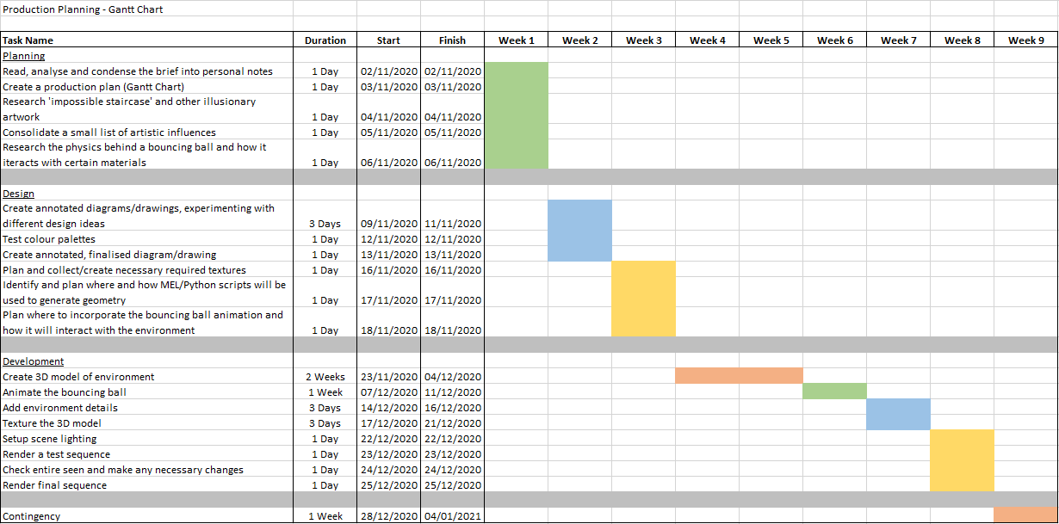

Figure 1: Production Planning - Gantt Chart (personal collection).

**Artistic Influence/Inspiration**

M.C. Escher is a world-renowned artist known for producing illusionary themed lithographs that play with perspective to create the impossible (The M.C. Escher Company 2020). Some of his most famous pieces of work incorporate an infinite flowing waterfall and impossible staircase, present within architecturally themed environments (Figure 2 & 3). What I love about Escher’s work is that the longer you stare at the image the more details you begin to discover over time. Moreover, Escher’s work is inspiring in the way that he can convey a clear focal point, despite his disuse of colour and sole focus on value adjustment to create a variety of shades of grey. The choice of shapes used in the architecture of his work consist mostly of straight lines, squared off edges, and few curves, which are not exceptionally complicated. I believe this to be why his work is particularly easy for the eye to follow, despite containing illusionary geometry, as his placement of staircases lead the eye to the focal point. He strikes a fine balance between complexity and simplicity, that I hope to convey in my own work.

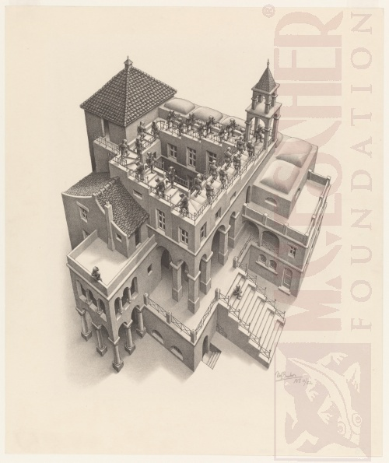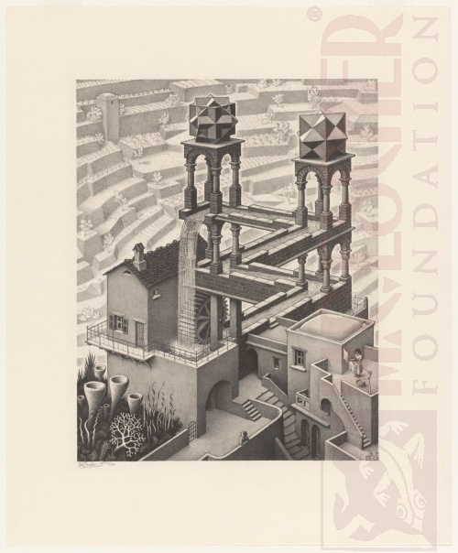

Figure 2 & 3: *Ascending and Descending* and *Waterfall* (M.C. Escher 1960, 1961).

Bucwah is an artist that designs complex impossible geometry, inside of primitive shapes such as cubes and tetrahedrons (Figure 4 & 5). What I find inspiring about Bucwah’s work is its sheer simplicity of using very few colours and shapes, to create something rather complex. The subtle difference in detail between *Vipassi Star Cube* and *Arsis Penrose*, of adding indentation, significantly amplifies the depth of the image to make it look more three-dimensional. Furthermore, his work is immersive in the way you can almost imagine yourself running through the geometry’s lanes, as if were navigating a labyrinth or maze. This kind of ‘pop’ and sense of depth is something that I certainly plan on recreating within my own work.

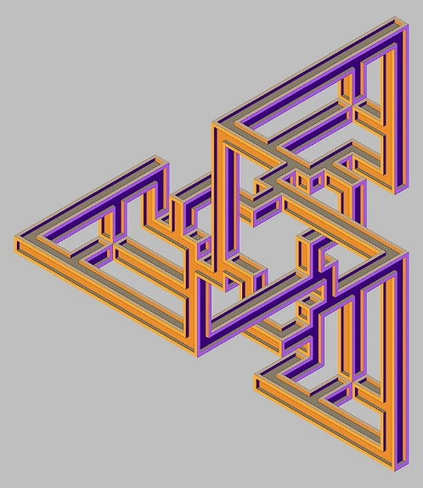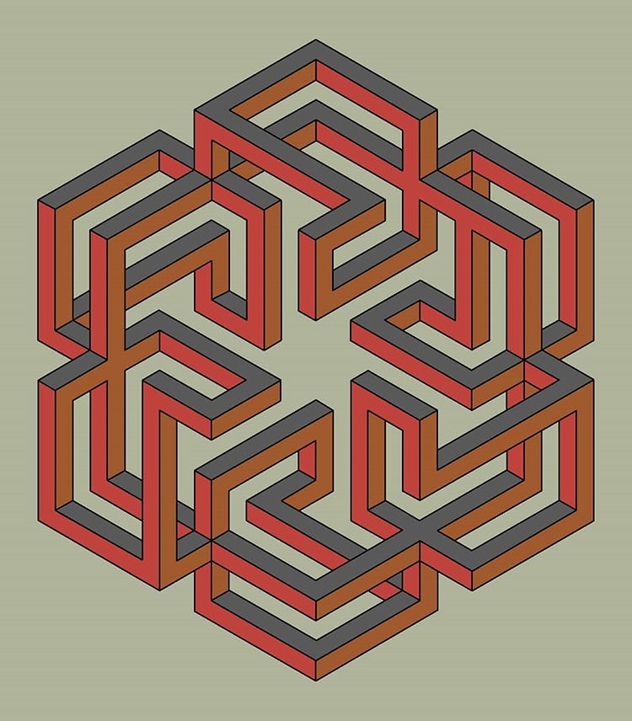

Figure 4 & 5: *Arsis Penrose* and *Vipassi Star Cube* (Bucwah 2020).

*Monument Valley* (2011) is a mobile indie puzzle game, based on navigating and manipulating a world of impossible objects, and optical illusions to solve puzzles (Figure 6 & 7). I believe the art style is nothing short of beautiful and has me completely captivated to recreate my own work in this exact style. In my opinion, Monument Valley is the resulting combination of Escher and Bucwah’s work, with a Japanese twist. More specifically, its geometric simplicity and use of highly saturated colours is what has me drawn to like this style the most. A comparison of the images below clearly demonstrates how the use of greens and blues can create an organic and relaxing feeling, whilst a dark vignette can convey the feeling of emptiness and sorrow.

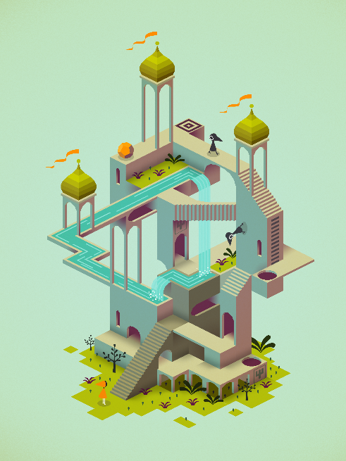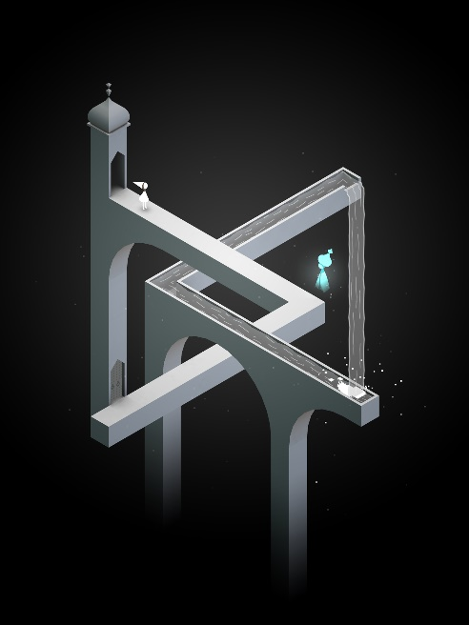

Figure 6 & 7: Screenshots taken from the *Monument Valley* press kit. (Monument Valley 2014).

**Design Process**

The main focal point of my environment is going to be a ball interacting with an impossible staircase. Therefore, I believe the most important part of my design process will be to identify and plan what the staircase will look like, the perspective it will be viewed from, and how the ball with interact with it. The initial process entailed drawing a rough sketch (Figure 8) and then creating a 3D model, based off the sketch, to understand how I would create the illusion within 3D space (Figure 9).

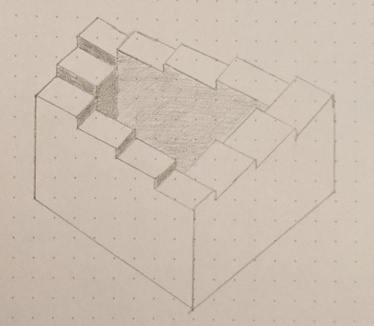

Figure 8: Impossible Staircase drawing (personal collection).



Figure 9: Impossible Staircase 3D visualisation (personal collection).

Due to the nature of an impossible staircase infinitely declining, the speed of the ball should realistically also infinitely increase with its descent. A secondary factor to consider is the balls likelihood to completely roll off the staircase, therefore I need to plan a way to implement barriers to stop this from happening straight away (Figure 10).

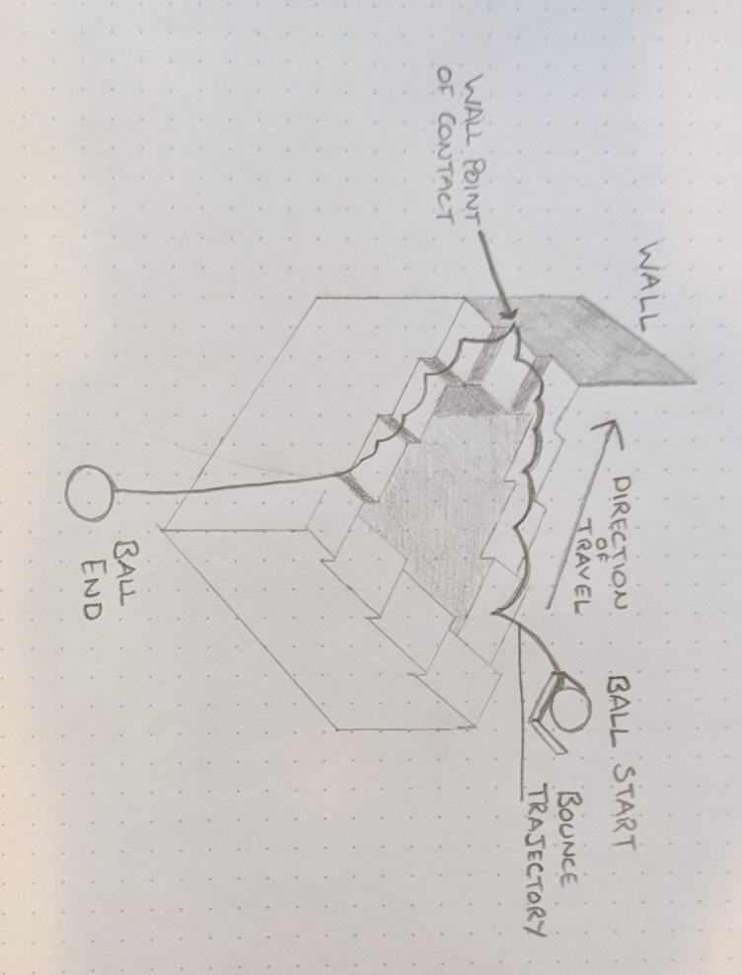

Figure 10: Ball animation and interaction planning (personal collection).

Illusionary works of art can be inherently confusing; however, this feeling can be mitigated using shape to lead the viewers’ eye. As my animation will be at the centre top of the camera view, I plan for my environment to emulate the shape of a triangle, with a wide base and narrow top, so the viewers eye is naturally led up. Moreover, using the rule of thirds by keeping most of the geometry central to the camera can keep the viewers’ attention where it needs to be (Figure 11).

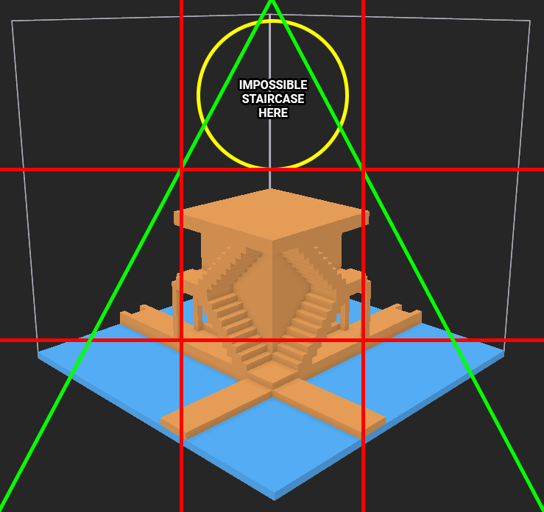

Figure 11: Test environment design and composition planning (personal collection).

**Lighting and Colour**

My colour palette of choice will consist of warm tones with a high contrast to convey the feeling of tranquillity and safety (Figure 6). I also plan for my environment to be well lit, emulating a midday sun to compensate the colours. Consequently, using muted tones and a lack of light can significantly change the mood and feeling of an environment in a negative way, to be eerie and full of mystery (Figure 7).

**Related Algorithms and Computer Graphics Techniques**

Due to the nature of my planned environment containing a plethora of different staircases, I would deem it most appropriate and efficient to create a tool that would procedurally generate them for me. The desired tool would allow the end-user to the define the dimensions and subdivisions of each stair, the total number of stairs they wish to generate and whether the staircase is ‘open’ or ‘closed’ (Figure 12).

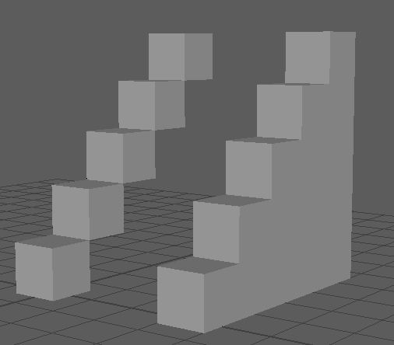

Figure 12: ‘Open’ and ‘Closed’ staircase comparison (personal collection).

The driving algorithm that would create the geometry would be solely reliant on the users specified inputs, encapsulated within a simple loop function. The desired function would create the number of specified ‘stairs’, from the users requested properties, then influence each ‘stairs’ transformation properties to generate a staircase. Finally, the function should also encompass appending all the ‘stairs’ to a group, so the end-user can benefit from easily managing many objects.

**References**

Bucwah, 2020. *Arsis Penrose* [digital drawing]. Available from: <https://www.instagram.com/p/B8a_9y4HuHB/> [Accessed 5 November 2020].

Bucwah, 2020. *Vipassi Star Cube* [digital drawing]. Available from: <https://www.instagram.com/p/CFcUFFdn5gi/> [Accessed 5 November 2020].

Escher, M.C., 1960. *Ascending and Descending* [lithograph]. Available from: <https://mcescher.com/gallery/impossible-constructions/> [Accessed 5 November 2020].

Escher, M.C., 1961. *Waterfall* [lithograph]. Available from: <https://mcescher.com/gallery/impossible-constructions/> [Accessed 5 November 2020].

The M.C. Escher Company, 2020. *M.C. Escher is famous, world-famous!* [online]. Available from: <https://mcescher.com/about/eschers-route-to-fame/> [Accessed 4 November 2020].

Monument Valley, 2014. *Monument Valley Press Kit* [screenshot]. Available from: <https://www.monumentvalleygame.com/mv1> [Accessed 5 November 2020].

Wikipedia, 2020. *Penrose stairs* [online]. Available from: <https://en.wikipedia.org/wiki/Penrose_stairs> [Accessed 4 November 2020].